CS 499 Module One Assignment Template
Connor Holohan

Complete this template by replacing the bracketed text with the relevant information.

- Self-Introduction: Address all of the following questions to introduce yourself.

  - How long have you been in the Computer Science program?
I started my BS in the Fall of 2023.

  - What have you learned while in the program? List three of the most important concepts or skills you have learned.
A tremendous amount of things. From android application design, to full stack development. Proper software security, machine learning. Several different languages and multiple different database types.

  - Discuss the specific skills you aim to demonstrate through your enhancements to reach each of the course outcomes.
The Full stack development course was very on rails, from start to finish the project was almost entirely dictated by the 100+ page project guide. I would like to demonstrate a full mastery of full stack development with a modern distributed managed db.

  - How do the specific skills you will demonstrate align with your career plans related to your degree?
It will be the biggest current show piece on my resume that will hopefully show that I can think critically and logically while interacting with modern tooling.

  - How does this contribute to the specialization you are targeting for your career?
Only by demonstrating general capability. Unfortunately I(and likely most other new cs grads) will be uncertain of an area of focus until we have had the opportunity to spend some time in the field. With the current job market, pursuing the ideal will likely take a backseat to simply being employed.

- ePortfolio Set Up:

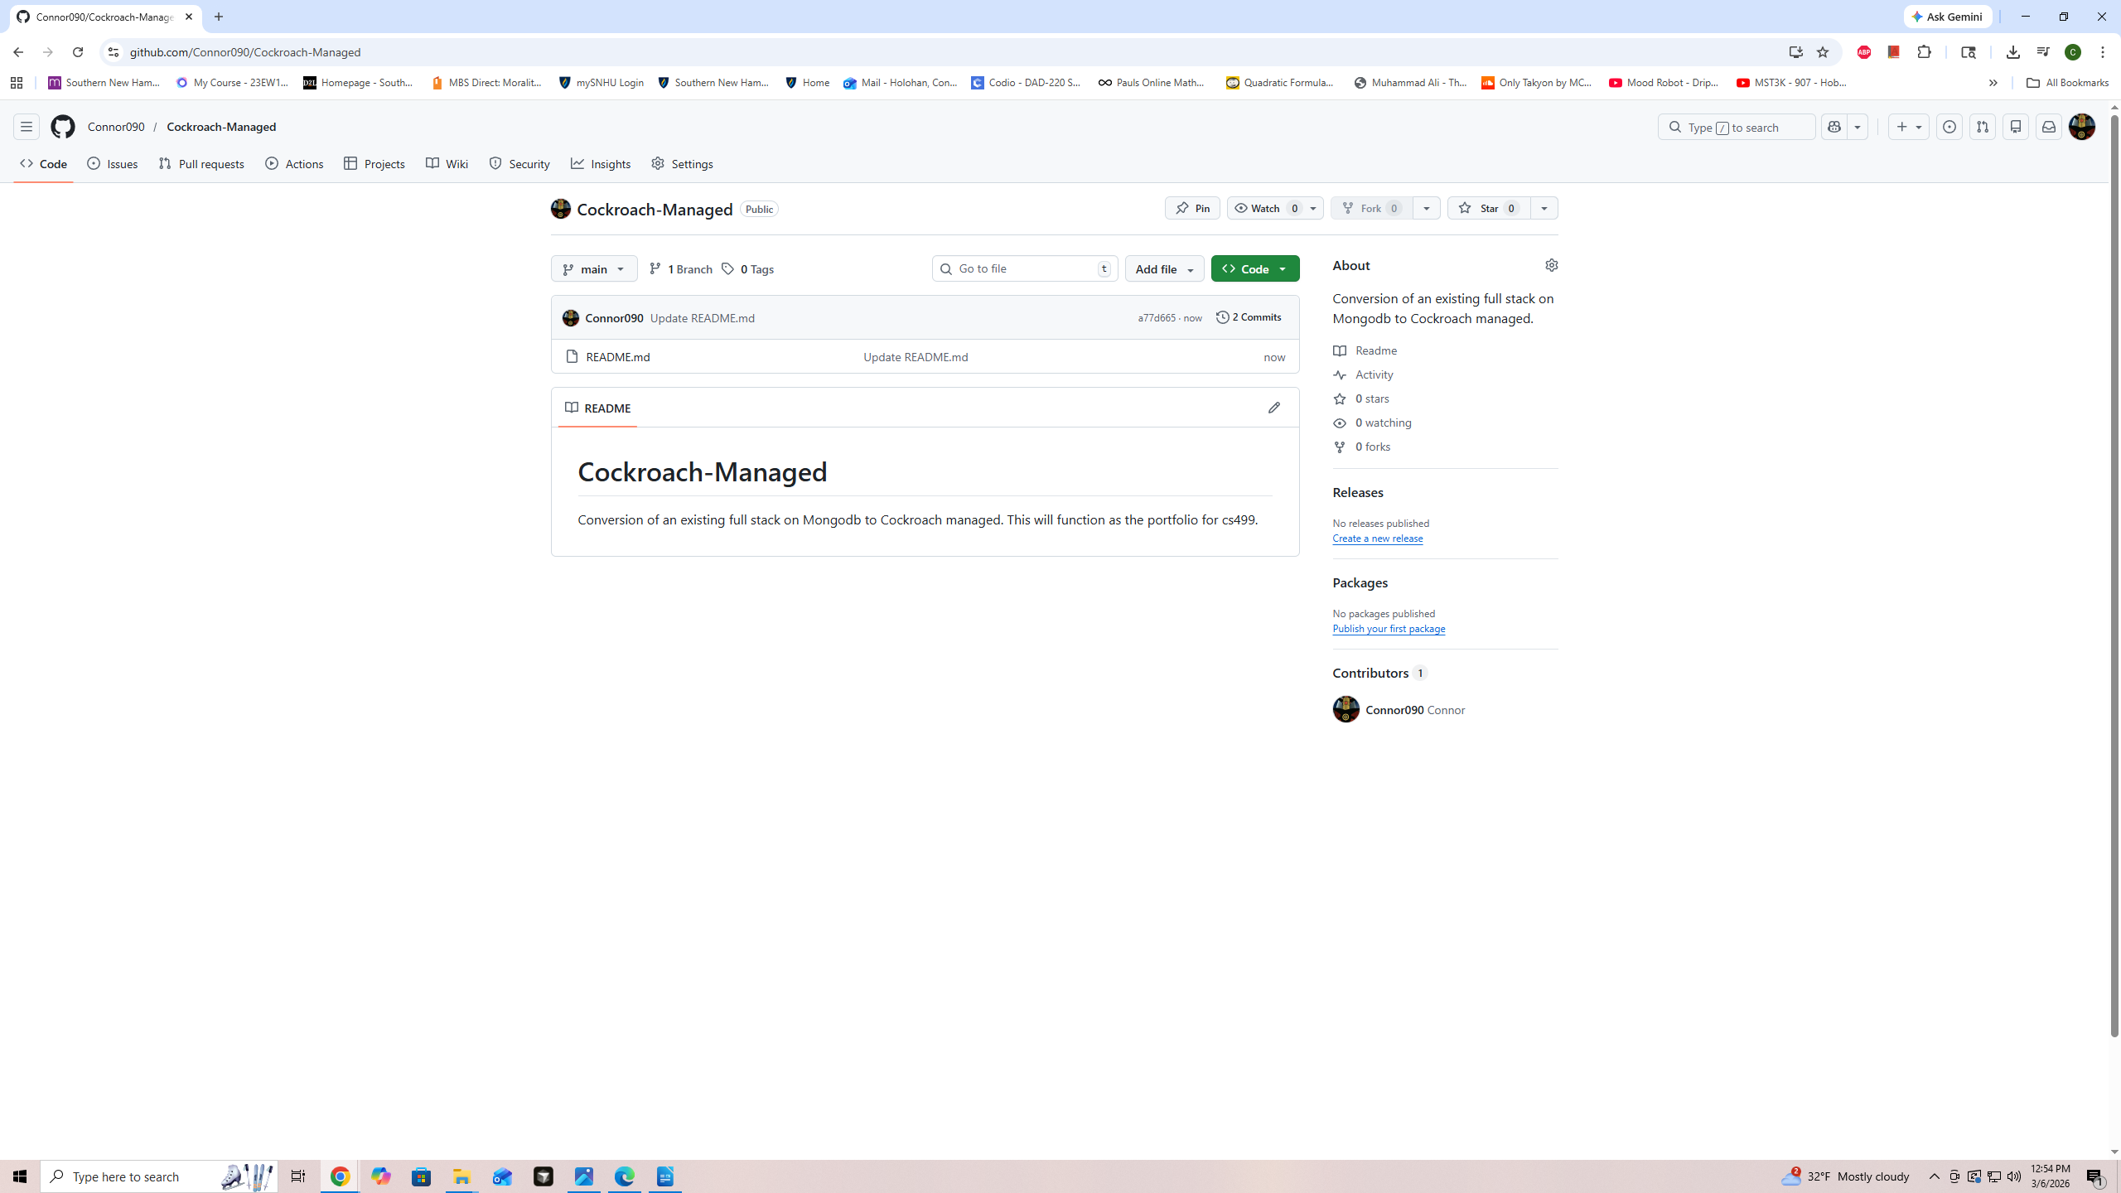

  - Paste a screenshot of your GitHub Pages home page with your URL clearly showing in the space below.

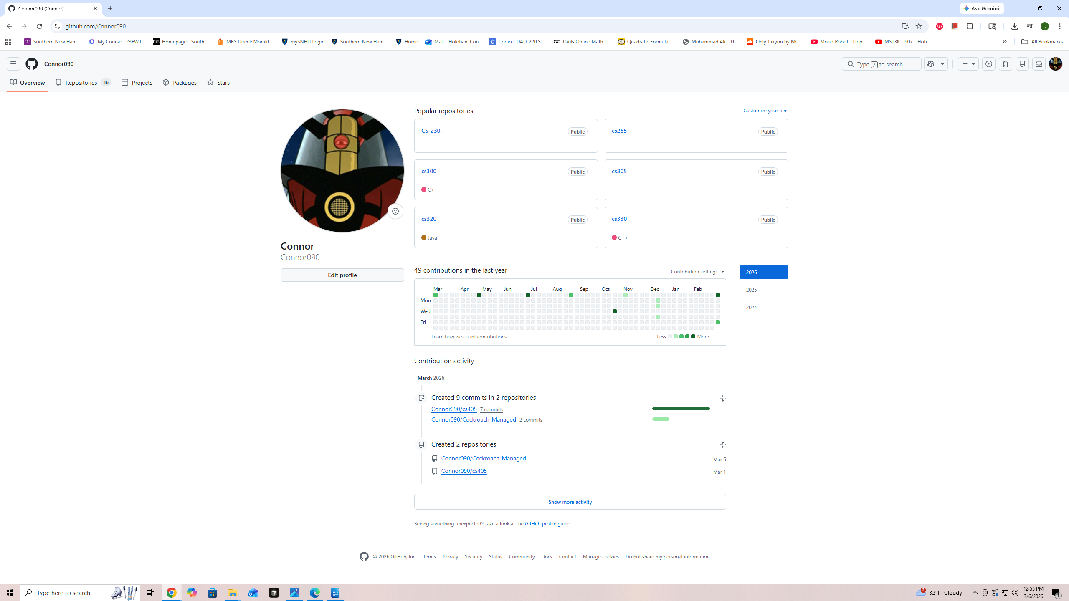

- Enhancement Plan:

  - Category One: Software Engineering and Design
    - Select an artifact that is aligned with the software engineering and design category and explain its origin. Submit a file containing the code for the artifact you choose with your enhancement plan.

As per our email my plan is a little more ambitious. I chose to use multiple artifacts from the cs465 FullStack course. The focus will be on converting the mongodb schema to cockroach managed db, the restful apis routing will stay the same but the rest of the code will need to be overhauled. Time permitting I will also attempt to convert the angular front end to an android application using android studio.

Note: Your artifact may be work from the following courses:

- IT 145: Foundation in Application Development
- CS 250: Software Development Lifecycle
- CS 260: Data Structures and Algorithms
- IT 315: Object Oriented Analysis and Design
- CS 320: Software Testing, Automation, and Quality Assurance
- CS 330: Computational Graphics and Visualization
- CS 340: Advanced Programming Concepts
- CS 350: Emerging Systems Architectures and Technologies
- CS 360: Mobile Architecture and Programming
- IT 365: Operating Environments
- IT 380: Cybersecurity and Information Assurance
- CS 405: Secure Coding
- CS 410: Reverse Software engineering
- IT 340: Network and Telecommunication Management
- IT 380: Cybersecurity and Information Assurance

    - Describe a practical, well-illustrated plan for enhancement in alignment with the category, including a pseudocode or flowchart that illustrates the planned enhancement.

I plan to enhance a full-stack application that currently uses MongoDB, RESTful APIs, and an Angular frontend. The main improvement will be converting the database from MongoDB to CockroachDB Managed. This change will allow me to show stronger database design, better system structure, and improved support for a cloud-based application.
The original application already includes a working frontend and backend. The Angular frontend communicates with the backend through RESTful API endpoints, and the backend stores data in MongoDB. While this setup works, I want to improve the application by moving to a managed relational database system. CockroachDB Managed will provide a more structured database design, better support for data consistency, and a stronger cloud architecture.

There is a significant amount of coding here. I will have to write pseudocode for each section.

For this category of enhancement, consider improving a piece of software, transferring a project into a different language, reverse engineering a piece of software for a different operating system, or expanding a project’s complexity. These are just recommendations. Consider being creative and proposing an alternative enhancement to your instructor.

Think about what additions to include to complete the enhancement criteria in this category. Since one example option is to port to a new language, that is the kind of scale that is expected. This does not mean you need to port to a new language but instead have an equivalent scale of enhancement. Underlying expectations of any enhancement include fixing errors, debugging, and cleaning up comments, but these are not enhancements themselves.

    - Explain how the planned enhancement will demonstrate specific skills and align with course outcomes.

      - Identify and describe the specific skills you will demonstrate that align with the course outcome.

This enhancement supports the three main computer science categories for the course. In software design and engineering, I will update the backend so it works with the new database and improve the overall structure of the application. In algorithms and data structures, I will review how data is retrieved and stored so that queries are more efficient. In databases, I will redesign the data model from a MongoDB document format into a relational structure that fits CockroachDB.

      - Select one or more of the course outcomes below that your enhancement will align with.

I will likely be utilizing most or all of the following course outcomes.

Course Outcomes:

- Employ strategies for building collaborative environments that enable diverse audiences to support organizational decision-making in the field of computer science.
- Design, develop, and deliver professional-quality oral, written, and visual communications that are coherent, technically sound, and appropriately adapted to specific audiences and contexts.
- Design and evaluate computing solutions that solve a given problem using algorithmic principles and computer science practices and standards appropriate to its solution while managing the trade-offs involved in design choices.
- Demonstrate an ability to use well-founded and innovative techniques, skills, and tools in computing practices for the purpose of implementing computer solutions that deliver value and accomplish industry-specific goals.
- Develop a security mindset that anticipates adversarial exploits in software architecture and designs to expose potential vulnerabilities, mitigate design flaws, and ensure privacy and enhanced security of data and resources.

- ePortfolio Overall Skill Set

  - Accurately describe the skill set to be illustrated by the ePortfolio overall.

A demonstration of full stack development and sufficient mastery to take an existing full stack and convert it to an entirely different type of database. This will be a combination of skills learned in the cs program at SNHU. From database design and management, all coding courses, software security, design and algorithms.

